15 Min. Morning check in Ms. Brooks Ms. Zavala other _____________
How are you feeling today?
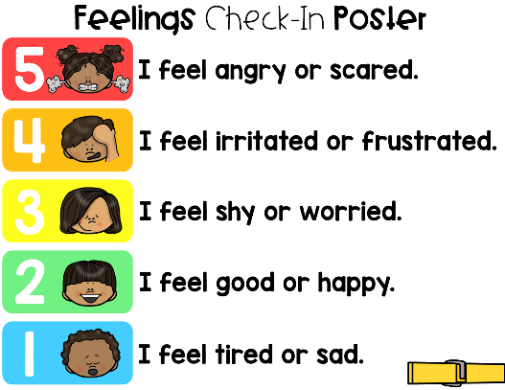
___________________________________________
_____________________________________________
_____________________________________________
____________________________________________
_______________________________ ______________________________________________

What are the main 6 classroom expectations for following directions:
_____ Raise my hand when I want to speak _____Transition appropriately
_____ Stay in my assigned seat ______ Complete assignments
_____ Voice Level 1 in the classroom _______ Using kind words & kind hands
Which classroom expectation is your focus skill of the day
______Raise my hand when I want to speak _____Transition appropriately
_____ Stay in my assigned seat ______ Complete assignments
_____ Voice Level 1 in the classroom _______ Using kind words & hands
How are you going to reach this goal? : ___________________________________________________________________________________
____________________________________________________________________________________________________________________________________________________________________________________________________________________________________________________________Where am going on the calm down channel_______________________________________
15 Min. End of Day Check Out Ms. Brooks Ms. Zavala other _____________
How did your day go?
S /T
___/__ 4- I followed all of the classroom expectations and completed all of my work
___/__ 3- I followed most of the classroom expectations and completed most of my work
___/__ 2- I followed a few of the classroom expectations and completed a few assignments
___/__ 1- I did not follow classroom expectations and did not complete my work

Did my day match what my teacher shared? YES NO

Why was your day successful? What did you do?
____________________________________________________________________________________________________________________________________________________________________________________________________________________________________________________________________________________________________________________________________________________________________________________________________________________________________
Why was your day not successful? What did you do?
__________________________________________________________________________________________________________________________________________________________________________________________________________________________________________________________________________________________________________________________________________________________________________________________________________________________________
How many days in a row have you had a successful day? ___________

