You are special , smart, and kind
Raise my hand when I want to speak  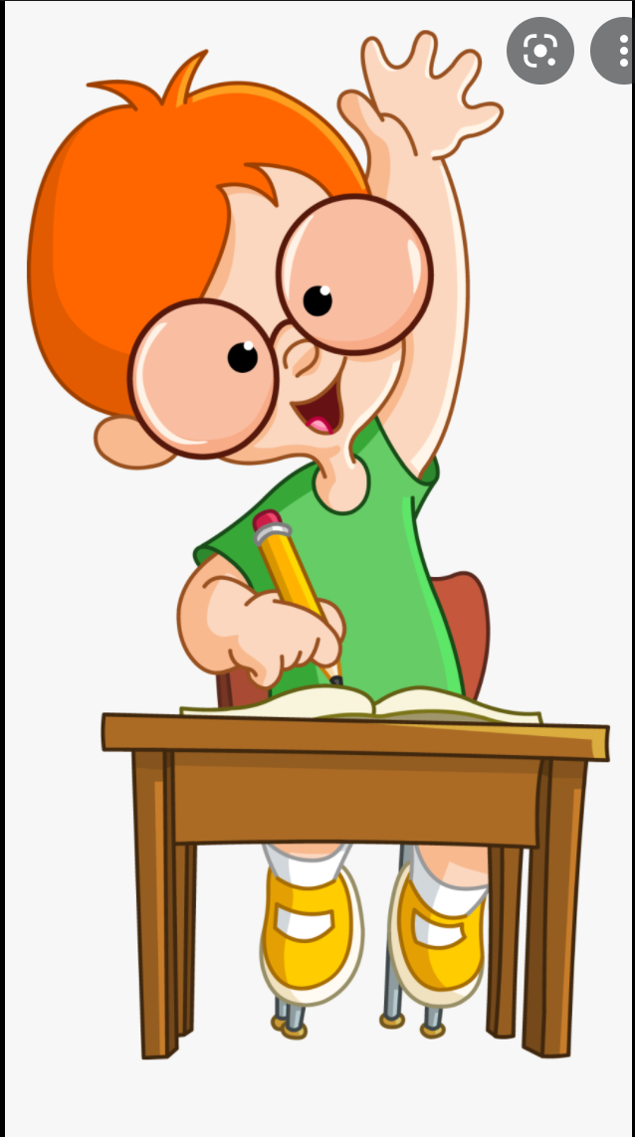 | Stay in my assigned seat  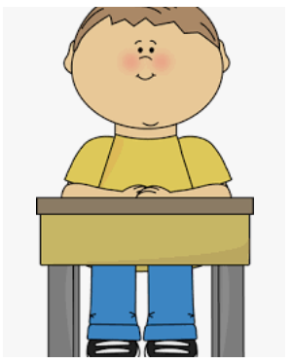 | Voice level 1 in the classroom  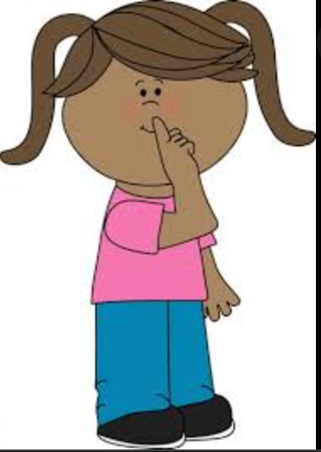 | Transition from place to the other safely  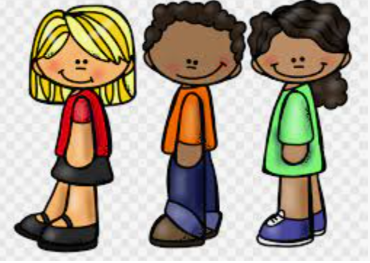 | Using Kind words  Please  Thank you  No, thank you  Stop please  You can do it  It’s Ok, I forgive you  I’m sorry. I’ll do better  Can I see that?  I really like your______  This is really cool | Keep my hands and feet to myself  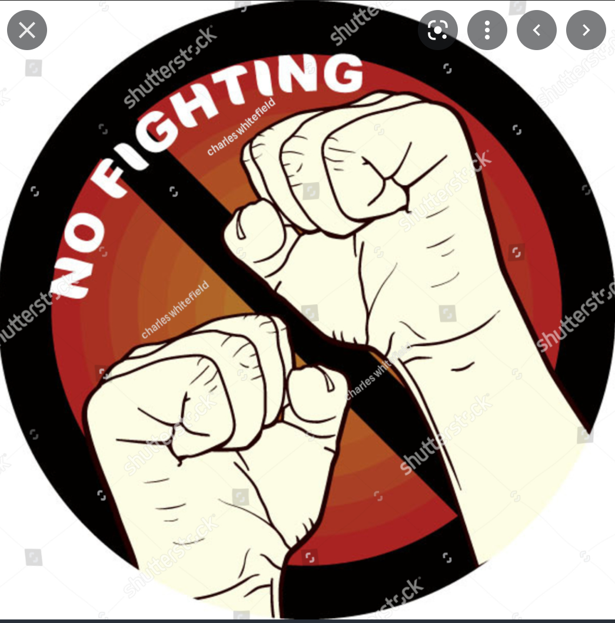
I can complete my work  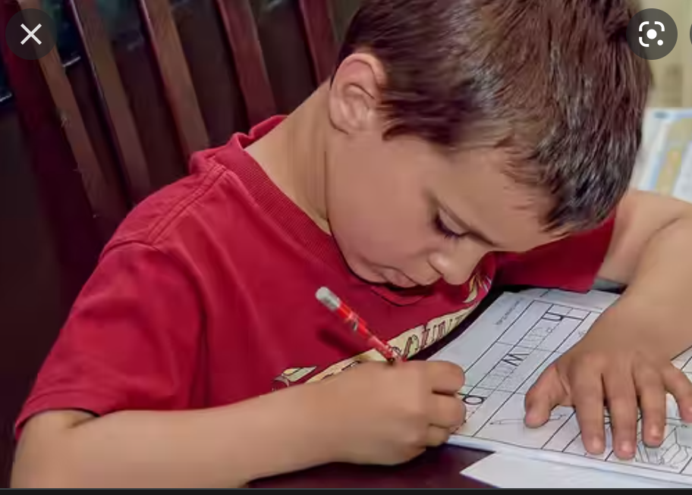 | Morning warm up | Reading exit ticket | Math review | Math Exit ticket | Test

